

**REAL-TIME EARTHQUAKE MONITOR**

Sistemas y tecnologías web (2021/2022)

Mathis BOSTON - [867063@unizar.es](mailto:867063@unizar.es)

**Summary :**

1 Description of the idea : 3

1.1 Aims : 3

1.2 Targeted audience : 3

1.3 Impact : 3

2 Similar sites: 4

3 Data source : 4

3.1 Provider : 4

3.2 Feeds 5

3.3 API Documentation : 5

3.4 Utilization 6

3.5 Problems or inconvenience 6

4 Main features: 6

5 Prototype, interface, views 8

# Description of the idea :

A French singer (Nekfeu) said : " Et si les cyclones étaient la somme de tous les derniers soupirs de la terre ? Et si les tremblements de terre étaient la somme de tous nos premiers pas ? Ca voudrait dire qu'on est tous liés." which can be translated by : "What if the cyclones were the sum of all the last sighs of the earth? What if the earthquakes were the sum of all our first steps? That would mean that we are all bound". These words inspired the genesis of this project.

## Aims :

The goal of this project is to make it possible **to visualize all the earthquakes which take place on all the surface of the globe**. The user can then adjust certain parameters to navigate through the data and visualize what interests him.

These earthquakes will be the way to connect people living on both sides of the globe who would never have had the opportunity to discuss otherwise. Indeed, the goal is also to **allow discussion with people located more or less far from a recent earthquake**.

Finally, the site will **provide information** on these natural phenomena and possibly **educate** some people on the instructions to follow during one of these phenomena.

## Targeted audience :

The site is intended for **all audiences**. Visualizing earthquakes may interest only **curious people** **and occasional visitors**. While some people looking to chat will have the opportunity to talk with people from all over the world and they will **regularly use as a message box and a place to discover new profiles.** The educational part will probably be **aimed more at users living in countries that are infrequently subject to natural disasters.**

## Impact :

First, it is expected to have at least an **educational impact** by allowing some people who have had no training in the reaction to a disaster phenomenon to acquire the basics of survival. This knowledge could be decisive if something happened during a trip for example. Otherwise, it's never a bad thing to accumulate knowledge even if you don't use it.

Secondly, it can have a **positive cultural impact**. It's a great way to **connect with people from all walks of life that you would never have met any other way**. It's a very good way to communicate with people from different cultures and to get to know them and interact with them. Often, virtual discussions are limited to people we already know or who look like us. Algorithms offer us people who are likely to please us. Here, people will be proposed only based on the location and the user can learn to discover, if he wishes, women and men.

# Similar sites:

Others websites offering an interactive real-time map of earthquake around the world already exist, like :

* <https://earthquake.usgs.gov/earthquakes/map/>
* <https://seismo.berkeley.edu/seismo.real.time.map.html>

Some applications already allow you to chat with people from all over the world, but often completely anonymously without necessarily sharing position. Others focus precisely on connecting people living in the same geographical area only, which gives them a common ground and facilitates discussion.

However, none of them use events to allow people to chat with each other. In fact, I don't know of any site allowing direct discussion between users around the world based on trivial events. This project is trying to mix the two by bringing together people from all over the world and using earthquakes to facilitate discussion.

# Data source :

## Provider :

The provider is a **very reliable source**. It is the USGS Earthquake Hazards Program of the U.S. Geological Survey (USGS) . It is the US government agency responsible for monitoring seismic activity on its territory and around the world using the Global Seismographic Network (GSN). It's a 152 station, globally distributed, state-of-the-art digital seismic network that provides free, realtime, open access data through the IRIS DMC.

Figure 1 Logo of the United States Geological Survey (USGS)

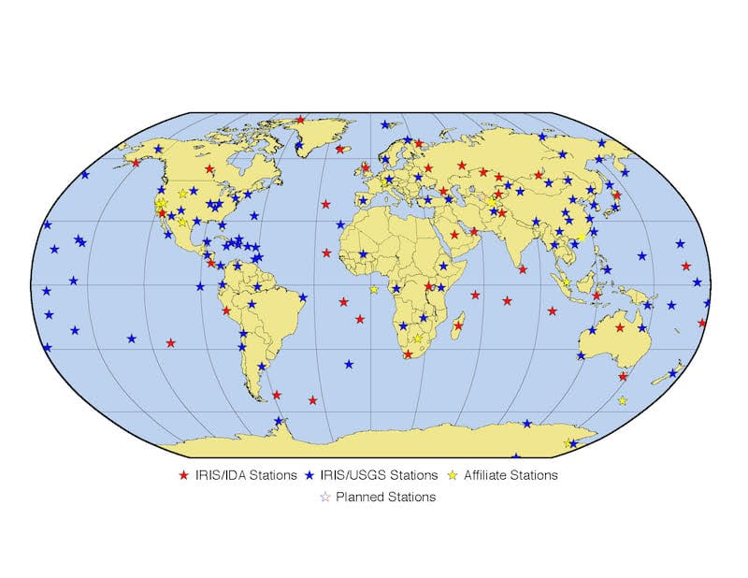

Figure 2 Distribution of the current station network

## Feeds

The USGS also provide several feeds updated every minutes which could be accessed for free.

**Documentation** can be accessed at the following URL :

* [https://earthquake.usgs.gov/earthquakes/feed/v1.0/geojson.php](https://earthquake.usgs.gov/earthquakes/feed/v1.0/geojson.php%20)

There is several feeds which give information according to the time interval compared to the current date and the magnitude of the earthquakes.

|  |  |  |  |  |
| --- | --- | --- | --- | --- |
|  | Past Hour | Past Day | Past 7 Days | Past 30 Days |
| All | *x* | *x* | *x* | *x* |
| Significant | *x* | *x* | *x* | *x* |
| Magnitude > 4.5 | *x* | *x* | *x* | *x* |
| Magnitude > 2.5 | *x* | *x* | *x* | *x* |
| Magnitude > 1.0 | *x* | *x* | *x* | *x* |

**Feeds** could be accessed at the following URL :

* [https://earthquake.usgs.gov/earthquakes/feed/v1.0/summary/[MAGNITUDE]_[INTERVAL].geojson](https://earthquake.usgs.gov/earthquakes/feed/v1.0/summary/%5bMAGNITUDE%5d_%5bINTERVAL%5d.geojson)

No methods or parameters could be applied.

## API Documentation :

The USGS also provide an open API and allows custom searches for earthquake Information using a variety of parameters.

**Documentation** can be accessed at the following URL :

* <https://earthquake.usgs.gov/fdsnws/event/1/>

**Data** could be accessed at the following URL :

* https://earthquake.usgs.gov/fdsnws/event/1/[[METHOD](https://earthquake.usgs.gov/fdsnws/event/1/#methods)[?[PARAMETERS](https://earthquake.usgs.gov/fdsnws/event/1/#parameters)]]

We will mainly use the **QUERY** **method** which will allow us to add parameters that allow us to customize the results obtained by modifying the parameters.

We will mainly use the following **parameters** :

* **Format** : can be csv, geojson, kml, quakeml, text, xml. We'll use geojson for displaying on a list and 2D map and probably kml for 3D map.
* **Time** : with starttime and endtime mainly to filter by time.
* **Location/circle**: Using latitude, longitude, maxradiuskm for creating a circle area of a certain size around coordinates.
* **Limit** : for limiting the maximum of results.
* **Maxdepth** and **Mindepth** : to filter by the depth of the epicenter of the earthquake.
* **Maxmagnitude** and **Minmagnitude**: to filter by the magnitude of the earthquake.

There is a query example :

<https://earthquake.usgs.gov/fdsnws/event/1/query?format=geojson&starttime=2022-01-01&endtime=2022-02-01>

The API has the following limitation :

* Number of call : unlimited
* Result cap : limited to maximum 20.000 earthquake result.

## Utilization

**Feed will be preferred over the use of query with the API** when possible (for default and preset filter for example). For more complex selection of earthquake, we'll user parameters of the API. Most useful ones have been descried on the last section.

We'll use this result to list and display recent earthquake and allow user to filter by time, location, depth, magnitude and maybe more. Data will also feed statistics and records which also could be filtered.

**More details will be presented in the "Main features" section.**

## Problems or inconvenience

The large number of earthquakes each month (around 10,000) will make it difficult to record these events over the long term. For example, the data for all earthquakes in February 2022 represents more than 10,000 lines and 7mb of storage. We quickly realize that we are between 50 and 100 mb per year and therefore very approximately between 500mb and 1gb of storage for 10 years. If we want to archive and host earthquake information over the long term, **storage will have to be taken into account.**

# Main features:

It should propose at least the same functionalities that the similar earthquake monitor website :

* Real Time world 2D map.
* Clickable earthquake point with detailed information about it.
* Link to 'Did you feel it' form or other links collecting data to help science
* Information about earthquake and safety instructions

We would improve it with :

* Chat with users located near the selected earthquake : first phrase should be : "Did you feel it ? "
* Real-time notification when an earthquake occur in 1 selected area (radius to be determined)
* 3D world map (use of cesium.js) <https://sandcastle.cesium.com/?src=Geometry%20and%20Appearances.html>

**This is a more detailed list of functionalities :** functionalities can be assessed according to the role of the users. We can distinguish 3 commons users roles :

* Visitor : User is not logged into an existing account.
* Logged: User has created an account and logged in
* Logged & Located: User logged in and provided their location and agreed to share it publicly.

**Account gestion :**

* **Visitor can register** : information are mail, username, password
* **Visitor can login** : information are mail, username, password (If login, visitor become logged user)
* **Logged can modify** his information. *(Password is advanced)*
* **Logged can input** his location.
* **Logged can choose to share or not** his location. (If location shared, logged user become located user)
* **Logged can unlogin**.
* **Logged can delete** his account.

**Latest Earthquake functions :**

* **All user can see X latest earthquake on a list and a map**.
  + Earthquake are linked from list to map. Focus one will focus the other.
  + Each earthquake will be represented as a point.
  + Each point is clickable which allow to display more information as : title, date & time, latitude, longitude, depth, magnitude, link to 'did you feel it' form, list of nearest users
* **All user can see X latest earthquake on a 2D map only**. List will be hidden.
  + Each earthquake will be represented as a point.
  + Each point is clickable which allow to display more information as : title, date & time, latitude, longitude, depth, magnitude, link to 'did you feel it' form, list of nearest users
* **Logged user can see latest earthquake on a 3D map**. *(advanced)*
  + Each earthquake will be represented as a point.

**Filter function :**

* **All user can filter by area** : Focus on an area to see more earthquake
  + Choose latitude, longitude and radius (Max radius because of 20.000 results limit).
* **All user can filter by magnitude** : Only show earthquakes within a certain magnitude range
  + Choose minimum and/or maximum.
* **Logged** **user can filter by** **time interval** : Focus on time interval to see more earthquake
  + Choose start time and end time (Max interval to be determined because of 20.000 results limit).
* **Logged user can filter by depth** : Only show earthquakes within a certain epicenter depth range
  + Choose minimum and/or maximum.

**Chat function :**

* **Logged user can start a chat** with located users who are near the earthquake selected.
  + A link to communicate will be available in the list of nearest users for each of them, when the details of the selected earthquake are displayed.
* **Located user will appear in the list of nearest users.**

**Stats function :**

* **All user can view statistics about earthquake**.
  + Country mas touched by earthquake. *(advanced)*
  + Closest located user of the latest earthquake
  + Average depth, magnitude
  + Daily, weekly, monthly, yearly, total earthquakes by area *( yearly, total & By area are advanced)*
  + Etc.
* **Located user can view more statistics about earthquake according to his location** (Reset when he changes it)
  + Nearest earthquake record
  + Number of earthquakes that occurred within a customizable radius and time interval.
  + Etc.

**Third-Party / External function :**

* **Visitor can register and login with Google or Twitter**.
* **Maps will automatically by centered** according to the position indicated by the user's browser.
* **Located user can ask for notification** or email when earthquakes occurs near his location.
* **All user can access to embed Twitter timeline** of official USGS accounts. *(maybe)*
* **Logged user could download long time archive** in an compressed archive format. *(maybe)*

# Prototype, interface, views